**Business Development**

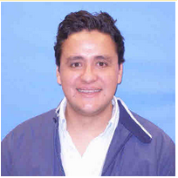**Julian Gelvez**

*Sr. Business Consultant*

I’ve been Southwest Airlines Employee for six years. Most of the time I’ve worked as International Planning consultant. My team develops business plans for all the cities/regions outside the United States where Southwest Airlines already serve or plans to serve in the near future. Recent business plans includes opening operations in Mexico, Costa Rica, Belize, and most recently Cuba. I’m originally from Bogota, Colombia. Came to the US eight years ago to do my Master’s degree in Business Administration. Back in Colombia, I graduated as Industrial Engineer and worked in different Airlines including the largest one in the country, Avianca. I’m passionate about diversity, culture, and economics in the U.S. and how they correlate with others in the region to create synergies that influence the Airline Industry.

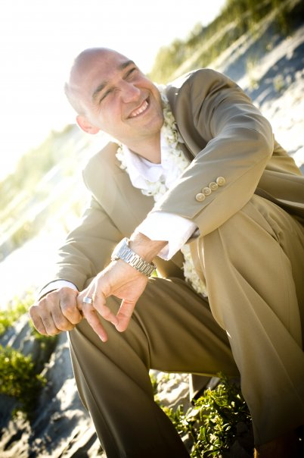**Evan Berg**

*Sr. Manager of International Planning*

In this role, Evan leads a team responsible for developing Southwest Airlines International 5 and 10 year network plans, including strategies for new market expansion. In addition, his team supports various ad-hoc analyses on competitors, performs aircraft evaluations and assesses macro-economic trends in regions of interest for expansion. Evan is passionate about the impact sustainable and quality air service development can have on developing economies and the quality of life of individuals who reside in these locations. Evan has served in multiple other roles since joining Southwest Airlines fifteen years ago. Evan is a graduate of The University of North Carolina at Chapel Hill.

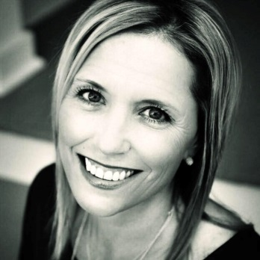

**Heather Tolmachoff**

*Sr. Business Consultant*

In 1995 Heather joined Southwest Airlines as Customer Service Agent. May of 1998, she moved to Dallas with a transferred to the Southwest Airlines corporate offices as a Corporate Recruiter. From there she’s held Leadership positions in the People and Training Departments. In 2003, she was promoted and moved back in the Airport Operations Department as a Change and Training Leader to supports efforts around a new reservations system, All-New Rapid Rewards Program and eventually was asked to lead the airport operations efforts around the AirTran and Southwest acquisition. In 2013, the Process and Innovation Team was formed with her efforts. But once again opportunity came knocking and she moved to Network Planning and Performance Team as a leader on the International Planning Team. She’s an avid runner, who has running over 10 marathons.

**Customer Services**

**\*Julie Boston-McGrath**

*Sr. Manager*

Julie started with Southwest 22 years ago. She spent her first 18 years in Ground Operations working in Customer Service at more than 5 of the airports Southwest serves. Julie has spent the past 4 years leading the Customer Services Team.

*Julie will assist Nora and Cory throughout the mentorship, but will not support her own mentor group

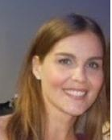**Nora Shafer**

*Manager*

Nora started with Southwest 19 years ago. She spent her first 4 years with Ground Operations, providing outstanding Customer Service to our Customers at the airport. She brought her Customer Service to Cabin Services (Inflight) for 8 years and transitioned to support Inflight in Labor Relations the following 5 years. Nora joined the Customer Services Team 4 years ago, helping her Team achieve the goal of becoming a World Class Hospitality Organization by providing Leaders and Employees with a coordinated Program that defines behaviors, expectations, and success factors.

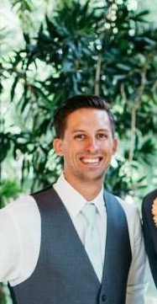**Cory Coons**

*Specialist*

Cory joined Southwest 4 years ago with the Customer Relations Team responding to Customer inquiries. He served in multiple capacities over his 3.5 years in Customer Relations, as a Writing Representative, Operational Leader, and Coaching Team Leader. He has spent the last year with the Customer Services Team helping to ARM Employees with the Southwest Airlines Hospitality Expectations, ENSURE our Leaders and Employees demonstrate Hospitality as defined by provided expectations, and EMPOWER Employees to differentiate our brand when the experience breaks down.

**Flight Operations**

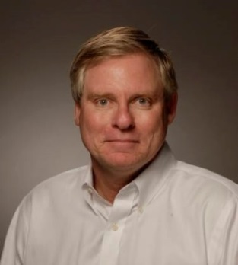

**Randy Smith**

*Sr. Director Training Standards and Procedures*

Randy is a native of Plano, graduating from Plano High School in 1974. Go Wildcats! He went on to attend the University of North Texas, earning degrees in Business Management and Marketing, and a minor in Economics, and his MBA soon thereafter. While still in school, Randy earned his Private Pilot’s License, flying in many capacities, in addition to spending time as a dispatcher, in ground operations and accounting. He joined Southwest in 1983 as Pilot, and has spent many years serving the Flight Training Team as a Recurrent Instructor and Check Airman. He currently serves as the Senior Director of Training, Standards and Procedures. Randy has received the Southwest Airlines President’s Award, one of the Company’s highest honors.

**Marketing**

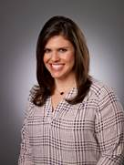

**Lynn Bruns**

*Sr. Business Consultant, Air Ancillary Products*

Lynn is responsible for revenue performance, marketing, and product development initiatives related to air ancillary products. Hired Dec. 31st, 2008, she began as Sr. Manager of product management & merchandising, leading a team that managed air ancillaries and travel products. Lynn recently transitioned to Sr. Business Consultant with focus on future product initiatives for air products. Prior to Southwest, Lynn’s past experience is in both travel & retail, specializing in ecommerce. At hotels.com/Expedia, Lynn held the position of Director of Merchandising, managing a team that developed promotions/campaigns, and worked with partners in the field to build campaigns that achieved revenue targets, as well as responsibility for product development optimization. At J.C. Penney she held various positions involving retail and merchandising, marketing, digital media, planning & allocation, ecommerce, P&L responsibility, and even a store department manager.

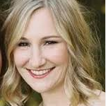**Erica Hood**

*Business Consultant, Digital Strategy and Brand Communications*

**People**

**Kembre Roberts**

*Manager, Wellness*

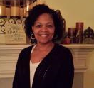**Terri Johnson**

*Team Leader, Health and Wellness Benefits*

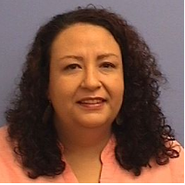

**Marisol Marquez**

*Coordinator II, Health and Wellness Benefits*

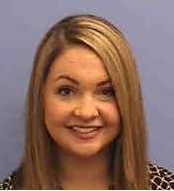 **Victoria Ward**

*Coordinator II, Health and Wellness Benefits*

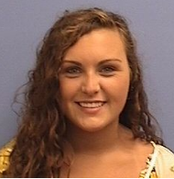**McKenzie Moore**

*Coordinator II, Health and Wellness Benefits*

**Technical Operations**

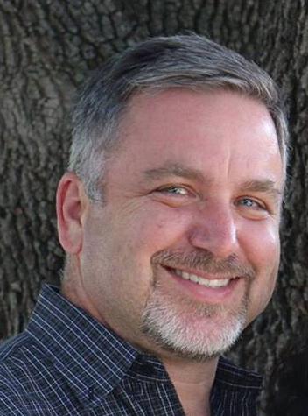**Barry Lott**

*Sr. Manager, Maintenance Programs and Reliability*

Barry has worked in aviation since 1983, including US Navy, McDonnell Douglas, Northrop Advanced, Systems Division, Airborne Express, ATA Airlines, Alaska Airlines, Atlas Airlines, and Gulfstream, earning his A&P License as a certified Mechanic. He currently serves as the Sr. Manger of Maintenance Programs, Maintenance Publications & Reliability. He oversees The reliability group, who is responsible for monitoring the aircraft performance and identify areas of concern or decreasing performance, the maintenance publications group, who customizes the manufacturer’s instructions to best fit the needs of the airline. In addition, he oversees the maintenance programs group who packages tasks based on similar intervals, access requirements, or systems for routine task performance. He says the best example is if you brought your car in for a timing belt replacement, this group would also look for what else should be done at the same time, such as water pump replacement, and other components. This group works closely with both reliability (to determine at what interval the task should be done) and Maintenance publications (to determine how to do the task).

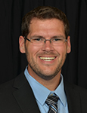**Tim Davis**

*Engineer, Structures*

A native of San Antonio, Tim graduated from UT-Austin with a degree in Aerospace Engineering. He has spent the past 7 years at Southwest, where he currently works as a Structures Project Engineer. His group implements structural modifications to the our aircraft and reviews the technical data from used aircraft that our airline purchases. He coordinates with the various groups within Tech Ops which impact the specific projects (i.e. Material/Purchasing if our project requires specific parts, Quality Control if specific inspection equipment is needed, MX Planning to create a forecasted schedule to address effected aircraft, Maintenance Programs to set-up documentation, etc.). In his spare time, he enjoys basketball, golf, and snow skiing and roots on the Spurs, Longhorns, and Rangers. He is currently pursuing his MBA at TCU and welcomed his first child, a boy, with his wife, Emily, last November.

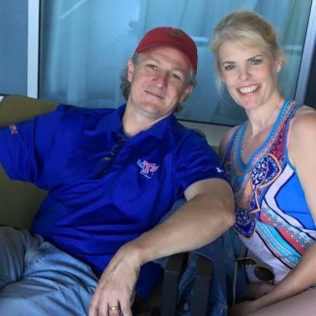**Scott Carpenter**

*Sr. Engineer, Structures*

Graduated Mechanical Engineering from Louisiana Tech University and MBA from Centenary College.  Served 8 Years in National Guard.  Worked for Rockwell International and Boeing in Military Defense.  Work was mostly updating older aircraft with modern avionics.  Worked at Continental Express (Expressjet) as Liaison Engineer supporting heavy maintenance prior to coming to Southwest.  At Southwest I am a Senior Engineer in the Structural Projects group.  We are responsible for fleetwide repairs and improvements to the structural areas of the aircraft to maintain safety and improve performance.

**Technical Operations Cont’d.**

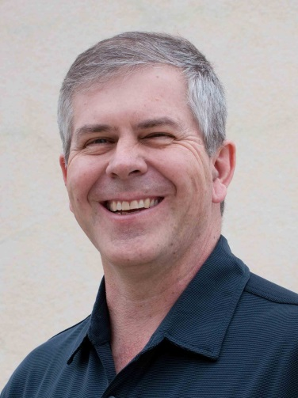**Ross Macarthur**

*Fleet Chief*

After receiving a Mechanical Engineering degree from the University of Oklahoma, Ross first worked at Boeing in Seattle before arriving at

Southwest Airlines sixteen years ago. While at Southwest Ross’s career has taken him from Systems Engineer to Engineering Manager, to Fleet Manager, and most recently to his current role as Fleet Chief. In this role Ross leads a team committed to using technical data to discover opportunities for improving the safety, reliability, or economics of the airline’s fleet of Boeing 737 aircraft.Ross is proud to live in Plano and even prouder to have a daughter who is a 2nd Year Learner at Plano Academy! Go Titans!

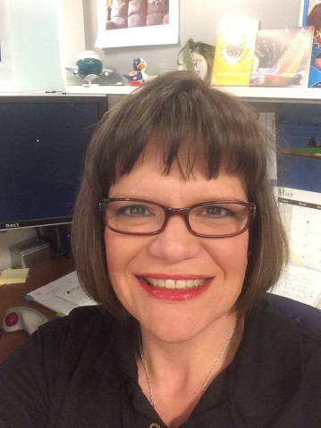**Ainsley Stelling**

*Sr. Engineer, Interiors*

Ainsley received her Bachelor of Science in Mechanical Engineering from Texas A&M University and her MBA from Clayton State University in Morrow, GA. She has worked as an Interiors Engineer spending 3 years at American Eagle, 5 years at AirTran, and the past 3 years at Southwest. Historically, she has been responsible for all things that fall within ATA 25 (Aircraft Equipment and Furnishings, aka. Interiors). Since being at SWA, her primary focus is on aircraft seating, passengers and crew. She maintains, designs, and coordinates modifications, monitor reliability and safety, and ensure our seats are airworthy in the eyes of the FAA and safe for our customers. She is a part of the team that designed the latest seat that will be going into the MAX aircraft in 2018. A fun fact about Ainsley is that she has two kids, Bichons named Bonnie and Clyde.

**Technology**

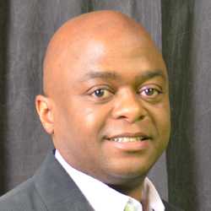

**Mark Ashley**

*Sr. Project Manager, Corporate Delivery*

Mark has spent 15+ years managing of driving and delivering complex multimillion dollar projects and programs. Currently, he serves as the

Program Lead for Crew Enhancements and is responsible for the delivery of new technologies and systems enhancements that support the Flight Operations (Pilots) and InFlight (Flight Attendants) teams. His current projects in delivery include enhancements to reroute and recovery tools that are used during irregular events (ie. weather) and complete replacement of the Crew Planning application (used to create schedules for Flight Attendants and Pilots). Mark previously served as the Director of Technology at Windstream Communications and was responsible for teams that developed and managed technology for eleven call centers and corporate offices in 29 states.

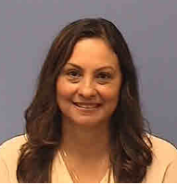

**Yeri Beltran**

*Analyst, Corporate Deliver- Crew Planning*

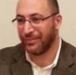 **Hazem Yassin**

*Sr. Analyst, Corporate Delivery- Enterprise Release*

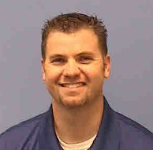 **Ryan Allen**

*Project Manager, Corporate Delivery- Crew Planning*

**Visual Communications**

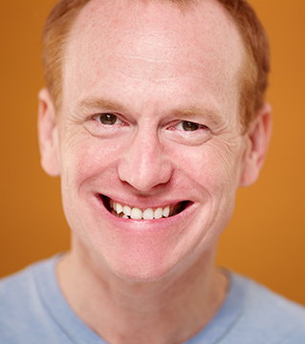**John Jones**

*Sr. Designer*

John began his career at Southwest in May of 1996 in the Customer Relations Department. After working as a writer and a telephone supervisor for four years, John began working as a graphic designer in the

Employee Communications Department. In 2007, Visual Communications became a standalone

department, and in 2008, the team was awarded the Heroes of the Heart award by the Company. In 2010, John was honored as a President’s Award recipient. Prior to Southwest Airlines, John received a Master’s Degree in Communications Studies from the University of North Texas, and instructed in the Communication Studies Department for two years before working at Southwest. John is a self-taught designer, and has been learning graphic design on the job for the past 16 years. John is also a professional actor, and has performed in numerous productions at various theatres in the DFW Metroplex for the past four years.

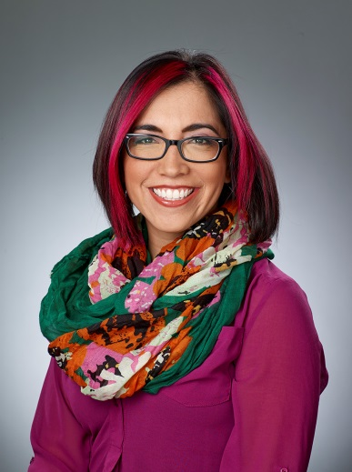

**Sonia Avila**

*Sr. Manager, Visual Communications*

Sonia Avila serves at the Senior Manager of Visual Communication for Southwest Airlines. Sonia and her team help to bring the stories of Southwest and its employees to life through print, digital, and video executions. As a designer for Southwest, her proudest career accomplishment has been serving as part of the core team for the rebrand in 2014. Prior to arriving at Southwest Airlines in 2004, she worked as a designer in the world of advertising. Sonia received her B.A. in Fine Arts from Texas Tech University. Outside of the office you can find Sonia working on one of her hobbies: figure skating (currently a judge in training for the United States Figure Skating) or ballroom dancing.

**Twitter:** @soniaissuper